1. As we saw, Use-Case Diagrams can help you describe the essential **functional requirements**.
2. Let’s put into action whatever you learnt by solving some challenges.
3. **Goal**:
   1. Goal is to draw a Use-Case Diagram that provides an overview of an elevator sytem.
4. Before drawing the diagram, let’s answer the following questions.
   1. What actors interact with an elevator?
   2. What are the main functions of an elevator?
5. Here is a simplified elevator control panel you can use as a reference for this exercise.  
   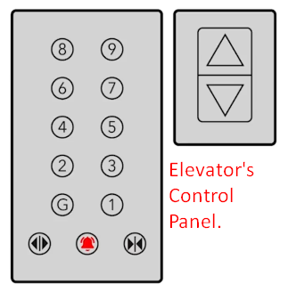
6. When defining the actors and use cases, take into account that elevators require regular maintenance and repair.  
   